EXPERIMENT:11: Change Hardware compatibility of a VM (Either by clone/create new one) which is already created and configured.

STEP:1: CREATE A NEW VIRTUAL MACHINE AND THEN KEEP IT IN THE TYPICAL.

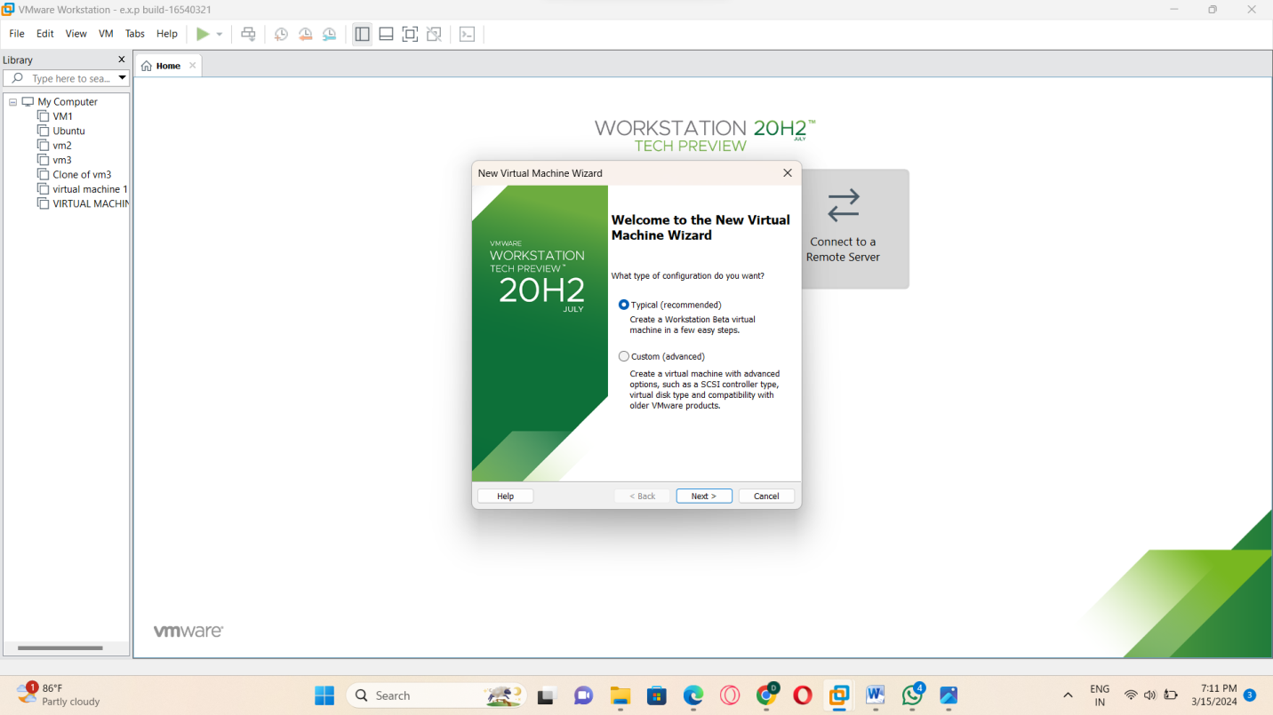

STEP:2:: SELECT THE GUEST OPERATING SYSTEM INSTALATION.

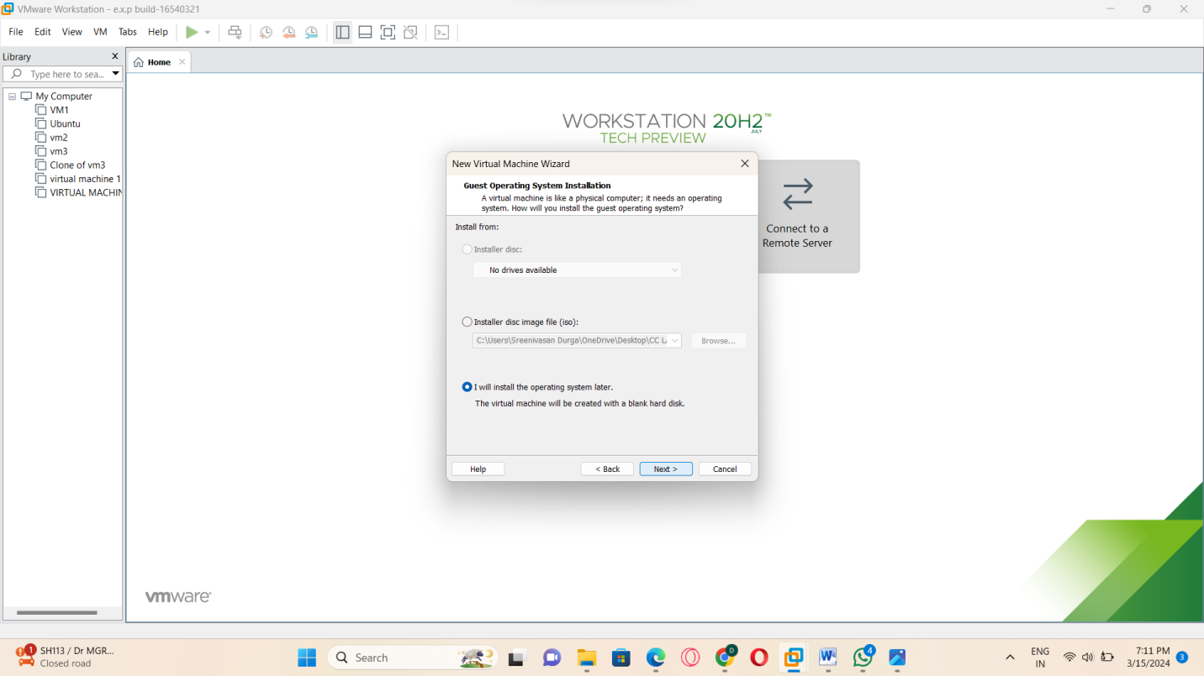

STEP:3: SELECT ANY ONE OF THE GUEST OPERATING SYSTEMS.

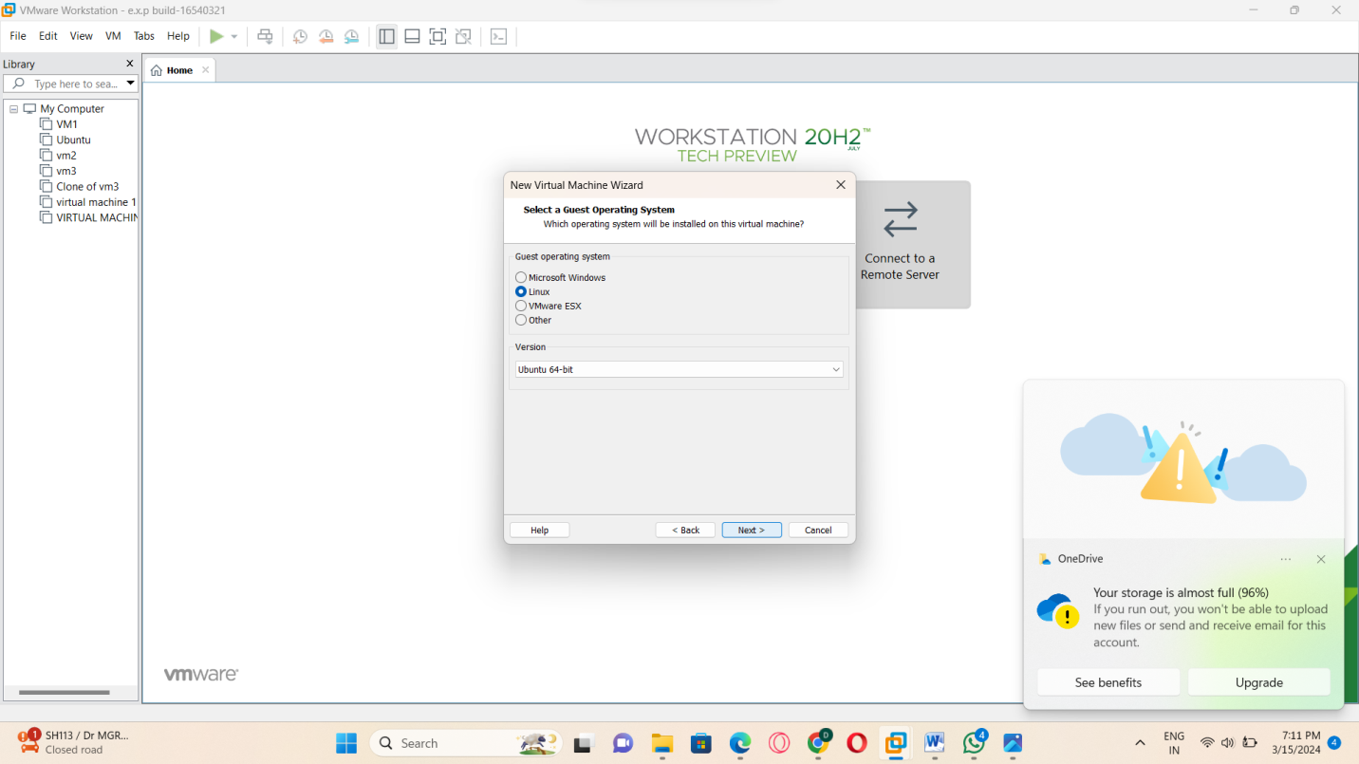

STEP:4: NAME THE VIRTUAL MACHINE.

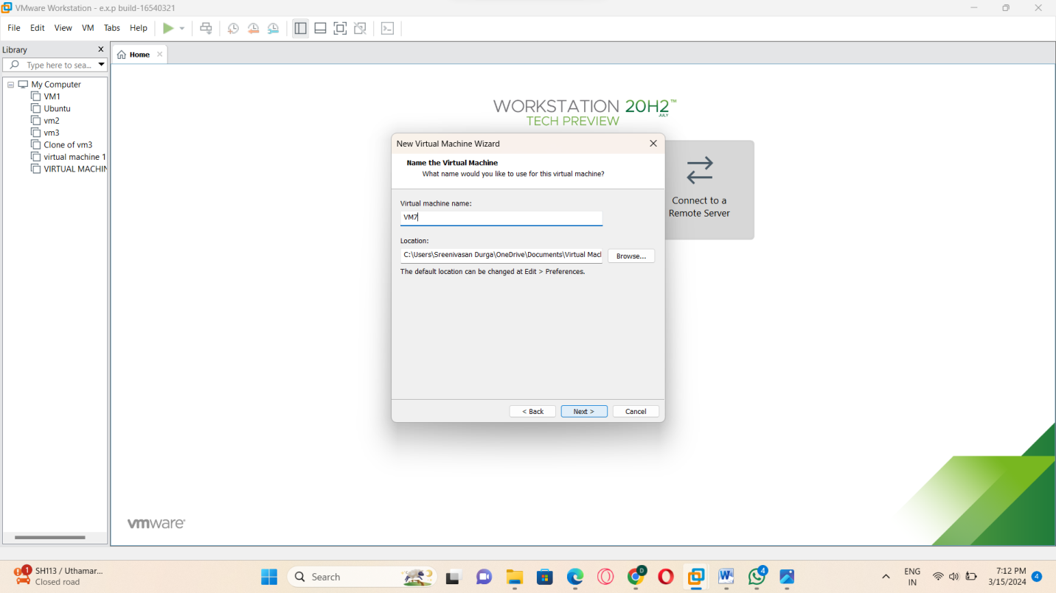

STEP:5: AND THEN NEXT SPECIFY THE DISK CAPACITY.

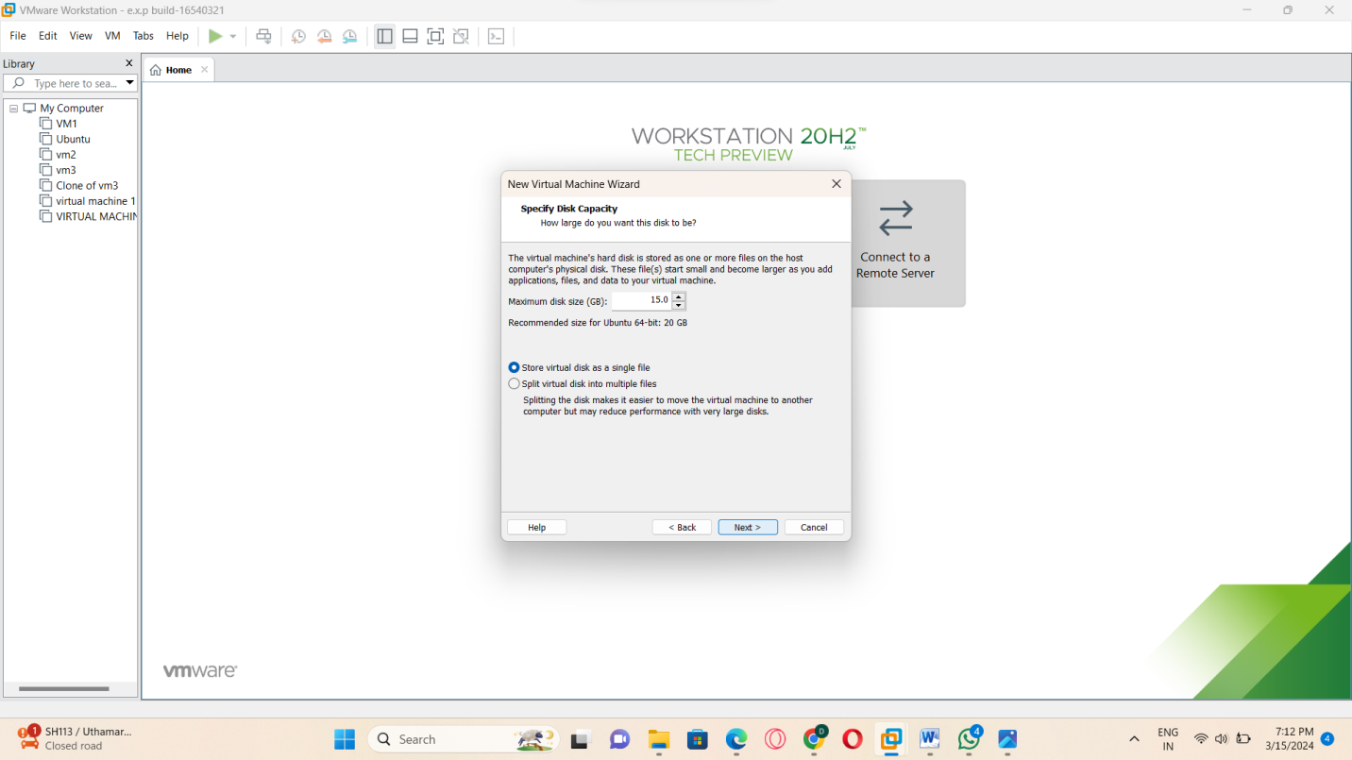

STEP:6: THEN THE CREATING OF THE VIRTUAL MACHINE IS READY.

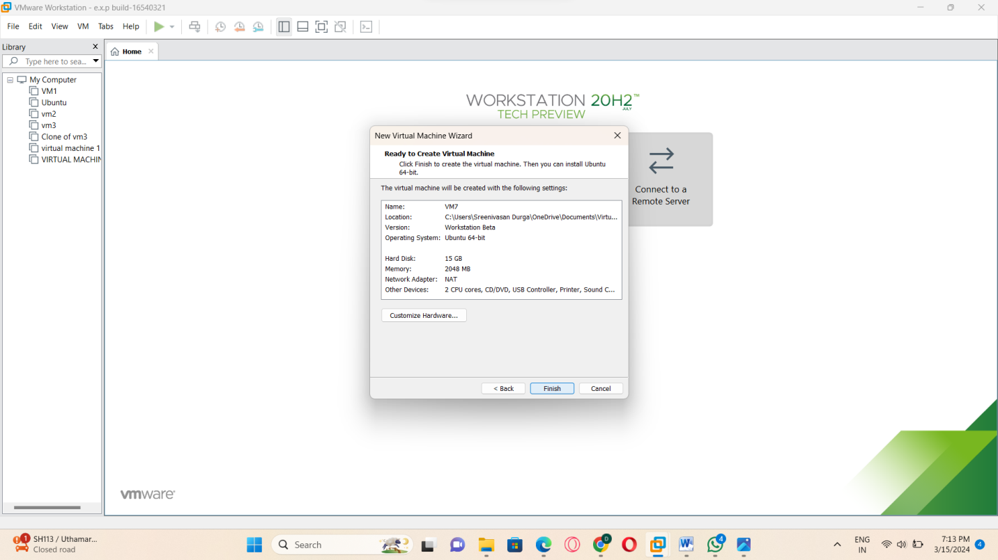

STEP:7:: THE OUTPUT OF THE VIRTUAL MACHINE BEFORE CHANGING THE HARDWARE COMPATIBILITY.

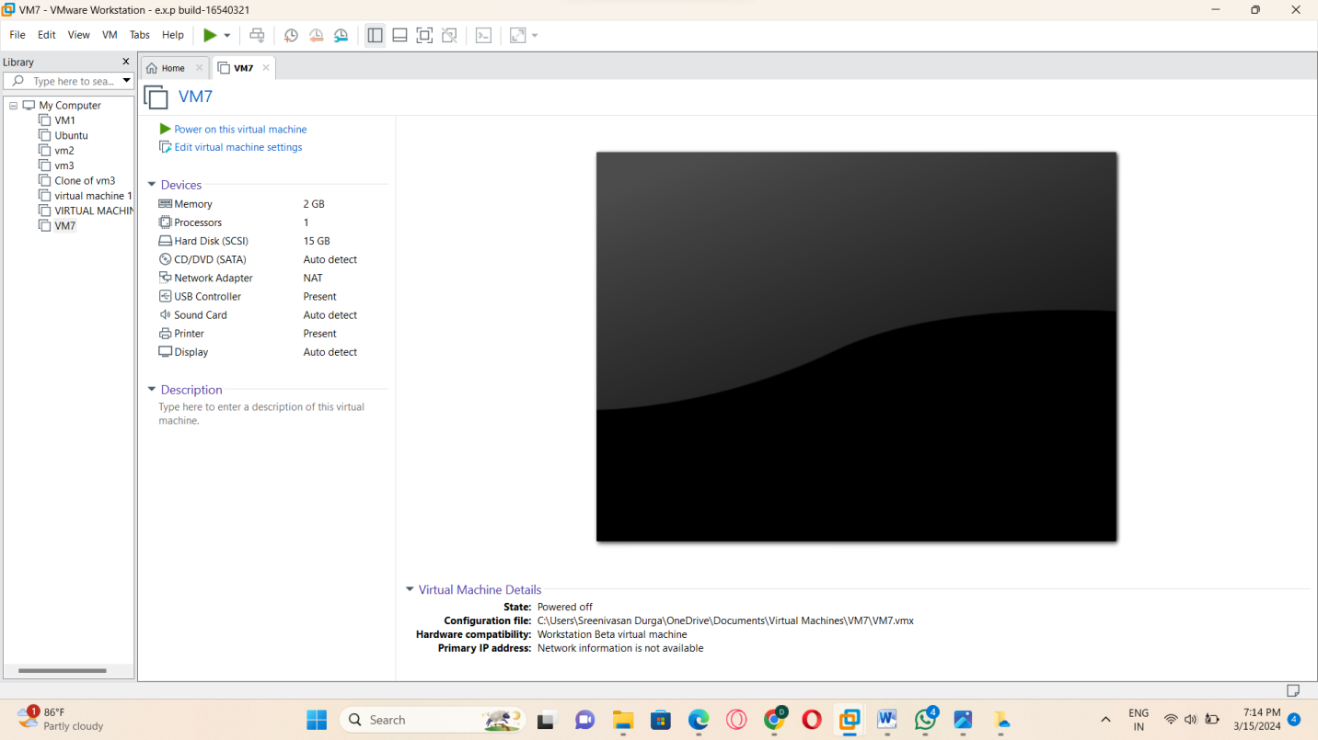

STEP:8: THE OUTPUT OF THE VIRTUAL MACHINE IN VM-WARE AFTER CHANGING THE HARDWARE COMPARTIBILTY.

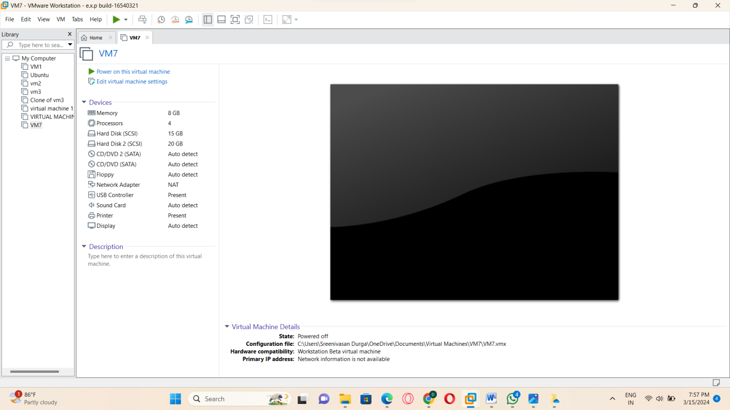

RESULT: THUS,THE PROGRAM FOR THE VM-WARE HAS BEEN EXCEUTED SUCESSFULLY.